**ASSIGNMENT-I**

Create circuit with Piezo alarm , PIR sensor , temperature sensor with below functionalities :

i)Alarm should sound in one manner if temperature is above 60 C.

ii)Alarm should sound with another frequency if motion is detected in PIR sensor

**CIRCUIT DIAGRAM :**

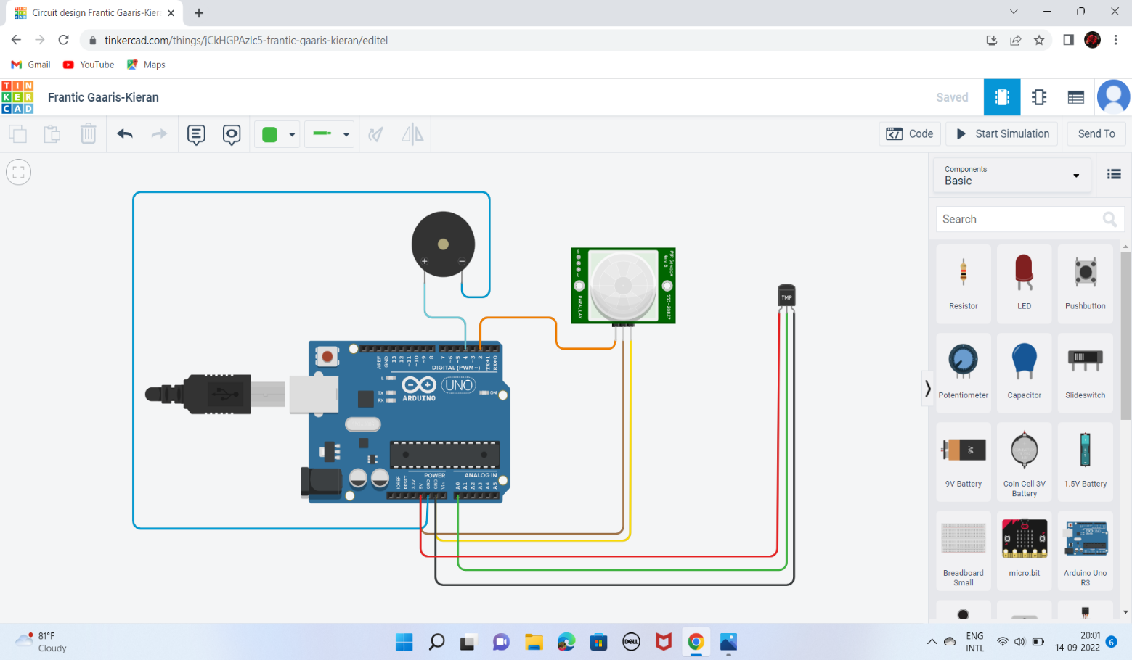

**ARDUINO CODE :**

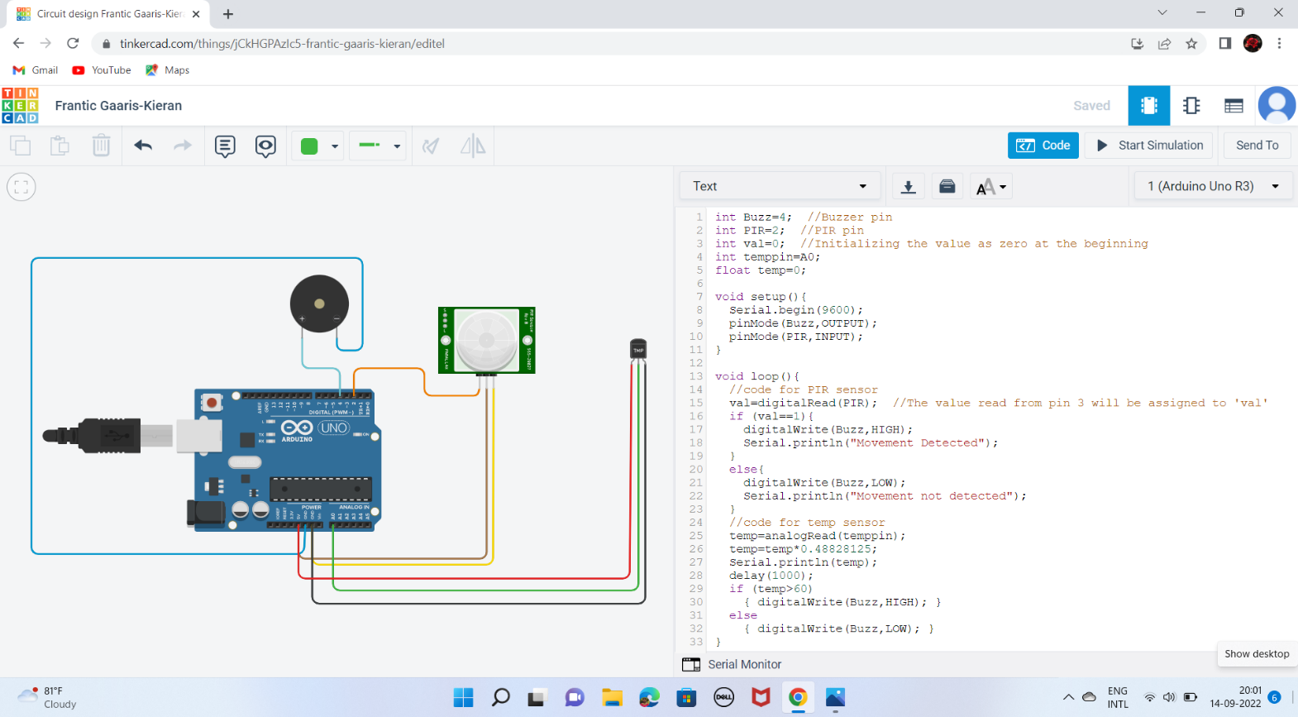

**OUTPUT :**

**No Movement and temperature<60 C**

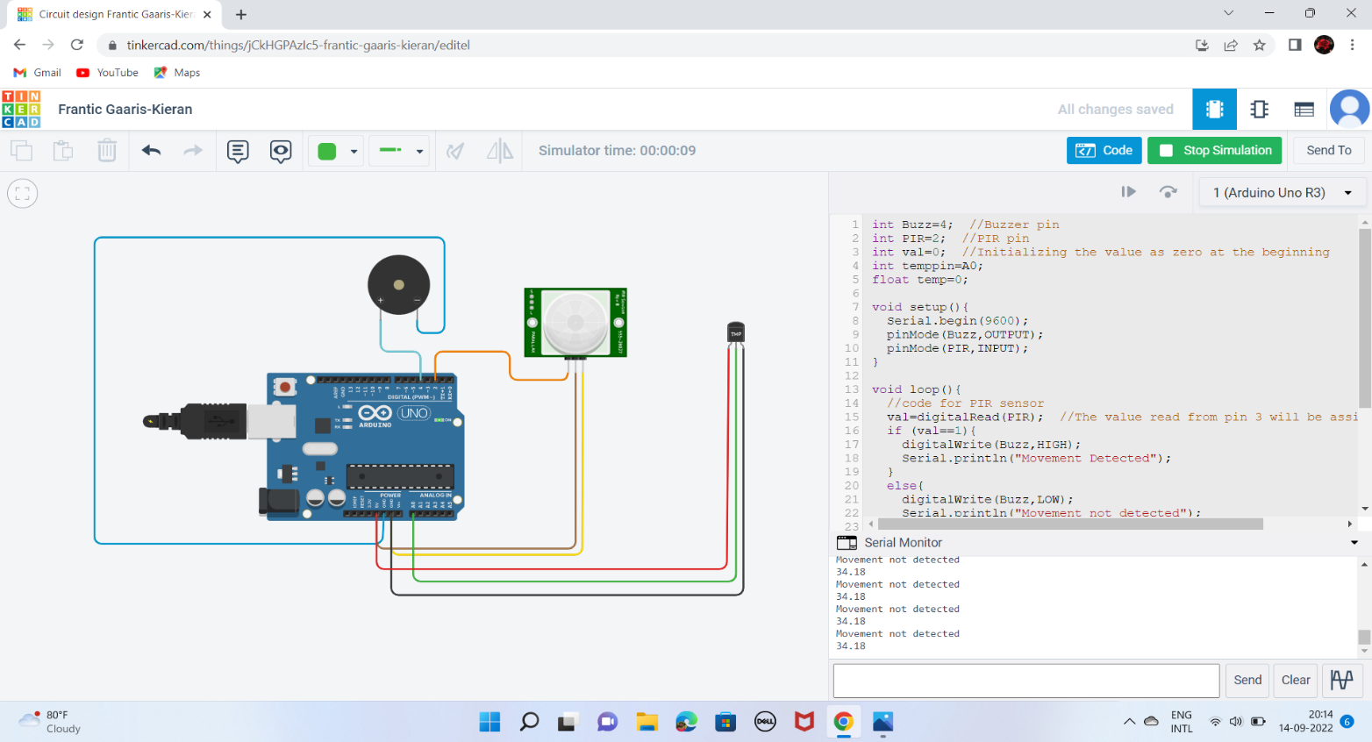

**Movement detected :**

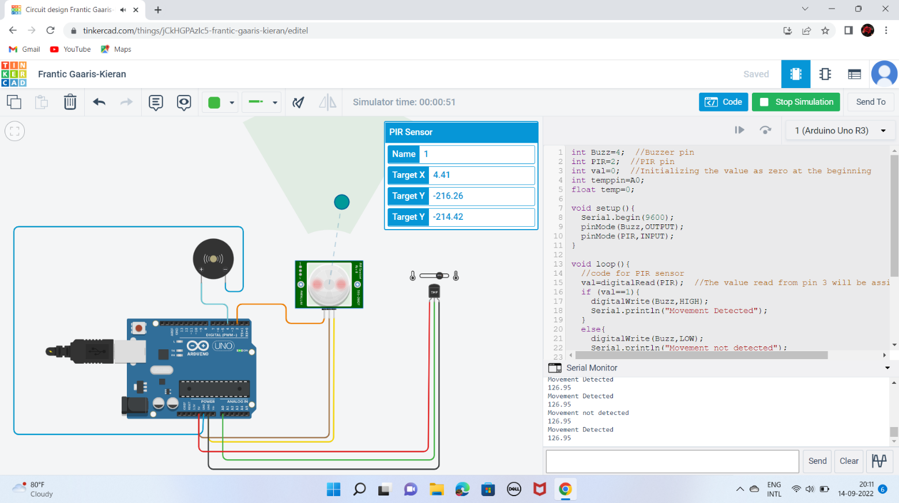

**Temperature<60 C :**

